**AZURE ACTIVE DIRECTORY**

The Azure Active Directory (Azure AD) enterprise identity service provides single sign-on and multi-factor authentication to help protect your users from 99.9 percent of cyber security attacks.

**“Your universal platform to manage and secure identities”**

* **Cloud based identity and access management services.**
* **We can create users and groups in Azure AD.**
* **You can assign licenses to users.**
* **You can also grant different roles to users in Azure AD.**
* **You can give access to resources in Azure to users defined in**

**Azure AD.**

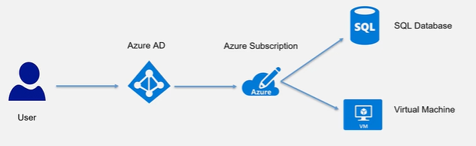

**AD pricing:**

**Azure Active Directory Free:**

This provides users and group’s management .It also provides on-premise directory synchronization, basic reports and self-service password change for cloud users.

**Azure Active Directory Premium P1:**

Designed to empower organisations with more demanding identity and access management needs, Azure Active Directory Premium edition adds feature-rich enterprise-level identity management capabilities and enables hybrid users to seamlessly access on-premises and cloud capabilities. This edition includes everything you need for information worker and identity administrators in hybrid environments across application access, self-service identity and access management (IAM) and security in the cloud.

**Azure Active Directory Premium P2:**

Azure Active Directory Premium P2 includes every feature of all other Azure Active Directory editions enhanced with advanced identity protection and privileged identity management capabilities.

**Below is the link for Azure AD pricing calculator.**

[**https://azure.microsoft.com/en-in/pricing/calculator/?service=active-directory**](https://azure.microsoft.com/en-in/pricing/calculator/?service=active-directory)